The following checklist outlines the steps to be followed when closing out USPS for calendar year-end.

NC1 Payments
______ Process NC1 pay types for life insurance premiums over $50,000 before the last payroll of the calendar year.
See Chapter 29, “Reporting Taxable Amount of Life Insurance Premiums” in USPS User Guide.
______ Run DEDLST for your city deduction code to identify if you have 25 or more active employees who pay city tax. If you do, then you will need us to file that city tax electronically for you.

TIN Verification (Optional)
______ Run SSAEVS to verify correct TIN for employees, verification accessed under:
USPS_ANN> W2MAINT>SSAEVS
The process should be run ahead of closing making sure all social security numbers are correct for W2 reporting.
****************************************************************************************************

Month-End Closing

SERS Retirement
______ Run the RETIRE program.
This program generates a report of earnings, deposits, and days paid for each retirement system. If necessary, adjustments can be made using UPSCN/ATDSCN. (AD, RE)

_____ Select the SERSREG option. On initial run select NOT to create the tape file.
_____ Review the SERSERR.txt report. Correct any errors.
_____ Review the SERSDET.txt report. Verify employee earnings, days and hours.
_____Verify the total contribution amounts listed on the report, equal the total deduction checks for the withholding plus any warrant checks written for pick-up on pick-up
_____ Verify contributions by employee, equal earnings times the applicable retirement percentage. Allow for rounding (within a few cents).
_____Review service credit days for all employees on the report.
_____ Once data is accurate, run SERSREG again and answer YES to create the SERS submission file.
(SERS.YYYYMMDDXXXX.SEQ)
_____Upload the SERS file to the eSERS website.
_____Run SERSMONTH before you begin processing payroll for the next month. The “Actual” option will clear the MTD accumulators on the 400/590 and 690 DEDSCN records. It also sets the New Employee flag on the 400 DEDSCN record to N and copies the following reports out to PAYROLLCD:
AUDRPT, ABS101, BENRPT, CHKSTS, AND SERSMONTH.
_____ Complete and submit SERS monthly reports and payments as required.
_____ Verify paperwork has been completed for employees listed on the report as ‘NEW.’
Balance Payroll Account (When statement is received from bank)
______ Run the USPRPT/CHKSTA program to reconcile checks.
______ Run the USPRPT/CHKSTS program to generate an outstanding check register.
Verify that you balance with the bank.
Accumulate Leave
______ Run BENACC if applicable.
*************************************************************************************************

Quarter-End Closing

Balance QRTRPT
______ Run the QRTRPT and select the Demand Option (N). The report shows quarter, fiscal, and annual totals.
______ In the ‘Totals” section of QRTRPT, the gross and adjusted gross should balance using a manual
calculation:
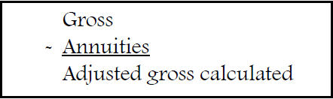
______ All deduction checks for the quarter should equal the total deductions showing on QRTRPT. This should be true for every deduction code. Be sure to verify the electronic transfers of Federal and Medicare payments as well.
______ The total gross showing on QRTRPT should equal the total of all payroll clearance checks created
during CHKUPD for the quarter.
*DO NOT CLEAR THE QUARTER yet…. More to do☺!!!

Balance W2REPT
It is recommended that you balance the W2REPT quarterly to minimize problems at Calendar Year-End
______ Run W2PROC. Check the W2ERR.TXT report for errors.
______ Complete and balance the W2REPT Reconciliation Worksheet for the quarter following the
directions on the worksheet.
______ Balance the deduction totals (taxes and annuities) on the W2REPT.TXT report with the totals
from the DEDRPT.TXT reports from the quarter.
______ Balance the gross amounts on the W2REPT.TXT report with the PAYRPT.TXT reports for the quarter.

______ If errors are discovered, check employees that had exception processing during the quarter
such as voided check, error adjustments, or manual changes in USPSCN.
If necessary, run the AUDRPT program. This can be useful in identifying these problems.

Balance Deductions
______ Run PAYDED to verify there are no outstanding deduction amounts.
To generate a non-zero deduction listing:
- Set the “Payment Option” = “ A”
- Pay Cycle = “ “ (blank)
- Deduction Codes = “ “ (blank)
On the DEDPRT.txt verify that there are no outstanding deduction amounts.
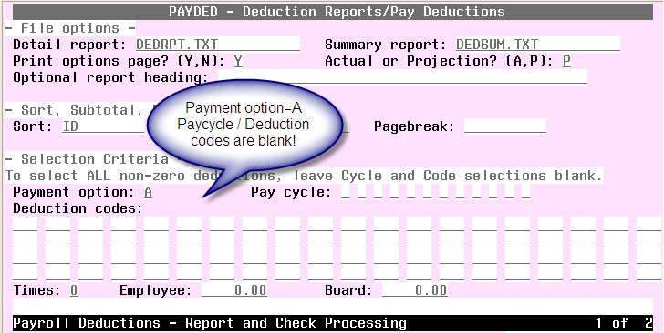

______ The total of all board paid amounts (if tracked on the system) should equal the total of all warrant checks to the vendor or deduction company.
______ Complete and file any required quarter-end submission forms for Deduction companies

City Withholdings
______ For city withholdings, take the taxable gross times the percentage to be sure the tax withheld and submitted are correct.
** Please note: Mobile employees could cause discrepancies.

ODJFS
______ Run ODJFSRPT setting the ‘Create a submission file’ prompt to N to generate a report only.

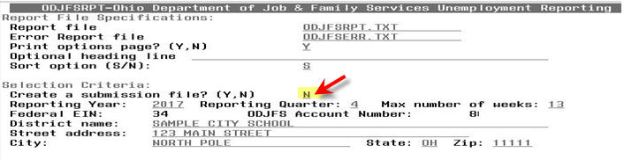
_____Check all totals carefully for accuracy. If necessary, adjustments can be made using USPSCN/ATDSCN. (AD OB)
**Example of the Ohio Tax Record for an Out of State employee:
- Employees who live in PA, but work in OHIO. Ohio Tax Record should look like this!
- The employee earns weeks & ODJFS wages, but NO Taxable gross should appear the deduction.
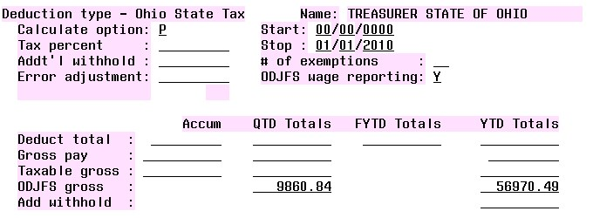

Common Problems:
- Employee has weeks but no money…. Verify the employee has not been paid, enter a stop date on the
002 Deduction
- Employee is Resident of PA and works in Ohio…. Shows gross wages Paid/Taxable Wages on ODJFSRPT- Make sure the Ohio Tax record has been setup for Out of State Employee as shown above.
ON ODJFS Gross wages should appear in QTD and YTD

______ When all data is correct, run the ODJFSRPT program again, this time indicating you want
to create a tape file for submission.

Optional Reports
______ Once all totals are balanced and you wish to generate file copies of all desired reports.
The following list is a minimum suggested for you to print:
USPRPT/EMPMST (all data)
USPRPT/ ERNREG (all data for the quarter)
QRTRPT (all data – demand report - Option N )
YTDRPT (YTD totals & a benefit statement for all employees or a pay group or individual employees)
WORKCOMP Report – Create a report of year-to-date expenditures for salaries and estimates Worker’s Compensation obligations. You will be prompt to enter a percentage rate to be used in computing workers compensation obligations. Your Treasurer may need to run this!! You’ll want to run this now. If missed, ACCESS would have to generate from the archived account.
OAPSE (USPS_LCL/OAPSE) Generate Report for Employee, Name, SSN, Birthday, & YTD Gross
********************************************************************************************

Calendar Year-End Closing

W2 Processing – Note- There are some new screens for W2 PROC
______ Check W2 abbreviations on all CITIES - DEDNAM records.
The W2 form will truncate the abbreviation to six characters even though the field in DEDNAM allows twelve.
______ For cities using either Regional Income Tax Agency (RITA) or the Central Collection Agency (CCA)
to report city tax information, verify the tax entity code, the appropriate RITA and/or CCA description, and RITA and/or CCA description are entered on the city USPSDAT/DEDNAM record.
______ Insure the OSDI four digit code appears first in the W2 abbreviation field in DEDNAM, followed by the
school name if space allows. The four digit code is required on the W2.
______ Using DEDSCN program, make any necessary changes to the YTD gross, YTD taxable
gross, and/or deductions for the W2 forms. Sources of these changes may be fringe benefits, life insurance cost, adoption assistance, third party pay, or a leased vehicle.
______ If an employee has reportable dependent care information that needs to appear in Box 10 of the W2 form,
there are two ways of reporting:
Enter the dependent care amount in the dependent care field on the 001 Federal record. <OR> If the DPCARE deduction type is being used no further corrections are necessary.
Questions on whether the dependent care is reportable, should be directed to your legal advisor.
______ Insure portions of annuities identified as insurance are adjusted on the deduction records so they are taxed
properly. If you are notified of this situation, you will need to increase the taxable gross on the 001, 002, and OSDI deductions for the amount identified as insurance and decrease YTD annuity amount by the amount identified as insurance. If the city honored the annuity when the amount was withheld, the city records should also be updated.
______ Run the program W2PROC saying “N” to “Do you want to create the W2 Tape file?”. This program generates the following files:
- W2ERR.TXT - Correct all errors
- W2REPT.TXT
- W2FORM.TXT - Forms for pin feed printers
- W2BREAK.TXT – Report show where w2 should be separated for employee distribution
- W2TAPE.SEQ - file used submission to Federal State Entities
- W2FORM.DAT – Print forms to laser
- W2CCA.SEQ (only CCA entities) – Use to create submission to CCA
- W2RITA.SEQ (only RITA entities) – Use to create submission to Rita
- W2CITY.DAT – Used for city submission and should not be printed
- W2PA.SEQ – file used for PA submissions.
_____Print the W2ERR.TXT and W2REPT.txt reports & verify the data.
**This program can be run as many times as necessary until all data is correct.
_____Run W2PROC again saying “Y” to “Do you want to create a W2 tape file?”
ACCESS WILL PICK UP TH E LAST W2FORM.DAT FILE TO PRINT W2’S!
_____ Mail all State and City tax forms REQUIRED BY DISTRICT.
______Send IT-3 Form to ACCESS for W2 submission. This form must be filled out and signed.
______ Run CALENDARCD to create calendar year end files for PAYROLLCD.
USPS_ANN\CALENDARCD :
Select “NOW” when prompt for now or later!
This program generates a standard set of calendar year-end reports.
______ Verify that the reports were copied to PAYROLLCD.
______ Have all your District employees EXIT out of USAS and USPS prior to running USPS_CY.
______ Run USPS_CY from USPS_LCL menu to backup of Payroll Files. These files are used by Auditors.
______ Create a HELP Desk Ticket (email fiscal@access-k12.org) indicating USPS_CY has been run and the district is ready for files to be verified.
You must wait for verification from ACCESS BEFORE PROCEEDING.
STOP!!!!! WAIT FOR ACCESS!!!
CLEAR THE QUARTER “ONLY IF ACCESS HAS TOLD YOU IT IS OKAY TO PROCEED!”

______ Run the QRTRPT program (Option Y) and zero out all data for the quarter and calendar year-end.
Note***Do not zero out fiscal year data.
______ To insure the data cleared correctly, run the QRTRPT program again (OPTION N) and verify that the year to date and quarter to date totals on the report are zero.

______Update any Rate changes or Employee Deduction for 1st pay of the new year.

You have completed the USPS Calendar Year End Closing Procedures!!
WELCOME NEW YEAR…. January payroll processing for the next calendar year can begin.
ACCESS will notify you when your W2’s are ready for pickup.

